InComm

TIBCO API Exchange Gateway

**User Guide**

Version <1.0>



|  |  |  |  |
| --- | --- | --- | --- |
|  | **Prepared By / Last Updated By** | **Reviewed By** | **Approved By** |
| **Name** | Dwiz Kumar |  |  |
| **Role** |  |  |  |
| **Signature** |  |  |  |
| **Date** | 4 June 2015 |  |  |

Table of Contents

1.0 Document Overview 3

1.1 Document Purpose 3

1.2 References 3

1.3 Definitions, Acronyms and Abbreviations 3

2.0 TIBCO APIX Gateway Configuration 3

2.1 Gateway 3

2.1.1 Validate & Update Configuration 4

2.2 Start asg-engine 5

3.0 Appendix A – Change Log 6

# Document Overview

## Document Purpose

This document is intended to provide guideline on setting up TIBCO API Gateway. As a pre-requisite,

It is required to have TIBCO API Gateway installed and configured successfully as per the product installation document.

## References

Use this section to fill-in reference documents used

|  |  |
| --- | --- |
| ***Document#*** | ***Document Title*** |
|  |  |
|  |  |

## Definitions, Acronyms and Abbreviations

Use this section to fill-in definitions of acronyms & abbreviations used in this document

|  |  |
| --- | --- |
| ***Term, Acronym*** | ***Definition*** |
|  |  |
|  |  |

# TIBCO APIX Gateway Configuration

## Gateway

1. Navigate to the directory in the Dev environment:

/home/tibco/TIBCO_HOME/tibco/cfgmgmt/asg/

1. Create .tar file of “VanillaScanReload” Project from previous environment (DEV).
2. Un-Tar it to the new(QA/Prod) environment in <<ASG_CONFIG_HOME>> location:

<<ASG_CONFIG_HOME>> tibco/cfgmgmt/asg/

(Eg: /home/tibco/TIBCO_HOME/tibco/cfgmgmt/asg/)

1. Start ConfigUI located at:

<ASG_HOME/bin>asg-configui

(Eg: /opt/tibco/asg/2.1/bin/asg-configui)

1. Open ConfigUI Portal at :

http://<hostname>:<configUIport>/ConfigUI/

(<http://localhost:9200> /ConfigUI/).

1. Login to the portal with appropriate creds (admin, admin)
2. “VanillaScanReload” project should be available under Project tab.

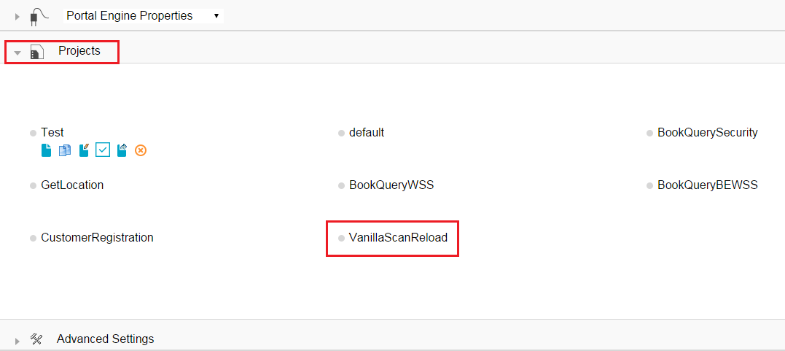

### Validate & Update Configuration

Once the project configuration is copied to the new environment, it is recommended to validate the configurations.

1. Click on the “VanillaScanReload” Project and select partner tab.
2. Verify all partners are present under the partners tab.
3. Check for partner name, partner group, partner issuer CA etc. are configured correctly.
4. Verify partner groups are configured correctly(optional).FOR VRS configuration, this step is not required at present.
5. Click on the Routing-> Façade operations tab and verify for
   1. Operation name : Appropriate Name for Operation (eg : RequestReload)
   2. Operation URI : URI of the API (eg: /fs/v1/Incomm/transactions/vrs)
   3. Operation method (POST, GET, PUT etc)
6. Click on the Target operations and verify for
   1. Target Operation Name : Appropriate Target Name for Operation(eg: RequestReload)
   2. Type : API Type(HTTP, HTTPS, ESB, SOAPJMS etc.)
   3. Target Operation Group : Appropriate Group Name ( eg: ScanReload)
   4. URI : URI of the API (eg: /transactions/vrs)
   5. Headers to Forward. (*,{query_string})
   6. Method (POST, GET, PUT etc)
   7. Update the host under target operation and provide the new environment’s (QA/Prod) IP address to it.
7. Click on the target operation groups and verify for
   1. Group Name : Appropriate Group Name ( eg: ScanReload)
   2. Type (Load Balanced)
   3. Target Operation: Appropriate Target Name for Operation(eg: RequestReload).
8. Click on the routing and verify for
   1. Operation Type: Facade Operation Name (eg: RequestReload)
   2. Routing Type: (TargetOperation/TargetOperationGroup)
   3. Target Operation: Target Operation Name( eg: RequestReload)
9. Go back to the partner tab and click on the partner api key.Verify for
   1. API key: valid API key (eg: 304-a08f3dce-bba7-4190-8831-f11f491f64a4)
   2. Partner: Appropriate Partner Name.
10. Click on the façade access tab and verify for
    1. Partner: Partner Name.
    2. Façade Operation: Facade Operation Name (eg: RequestReload)
    3. API key: valid API key (eg: 304-a08f3dce-bba7-4190-8831-f11f491f64a4)
11. Click on validate for project validation.

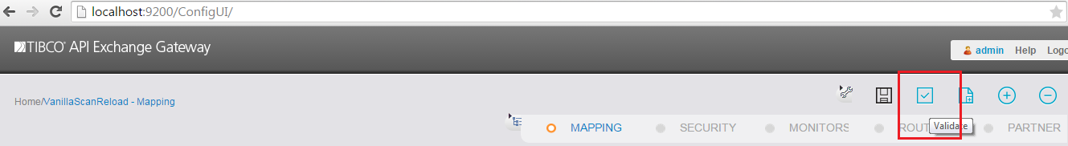

## Start asg-engine

1. Navigate to the directory <ASG_HOME/bin/>.

(Eg: /opt/tibco/asg/2.1/bin/)

1. Run the below command to start the asg-engine.

nohup ./asg-engine -u asg-caching-core -a VanillaScanReload 2>&1 &

*(Note : Please make sure the parameter (-a project name) is case-sensitive for proper operations of ASG.)*

# Appendix A – Change Log

|  |  |  |  |  |
| --- | --- | --- | --- | --- |
| ***Version Number*** | ***Changes Made*** | | | |
| Vx.y | Initial baseline created on xx-Feb-2014 | | | |
| Vx.y |  | | | |
| **Section No.** | **Changed By** | **Effective Date** | **Changes Effected** |
|  |  |  |  |
| Vx.y |  | | | |
| **Section No.** | **Changed By** | **Effective Date** | **Changes Effected** |
|  |  |  |  |
| Vx.y |  | | | |
| **Section No.** | **Changed By** | **Effective Date** | **Changes Effected** |
|  |  |  |  |